RESPONSIBLE AI NOTES
Unit Topic:
“Fair AI, Fair Future — Ownership in the AI Age”
Prepared for: Undergraduate 2nd Year Students
Subject Area: Responsible AI / AI Ethics
Format: Theory Notes with Diagrams

1. Introduction
As Artificial Intelligence systems move from research labs into everyday products — writing assistants, image generators, hiring tools, loan-approval systems — two questions have become unavoidable: is the system treating everyone fairly, and who actually owns the data, the model, and the output it produces? ‘Responsible AI’ is the field that studies how to build and deploy AI systems that are fair, transparent, accountable, and respectful of ownership and rights.
This unit explores the theme ‘Fair AI, Fair Future: Ownership in the AI Age’ — looking first at what fairness means for a machine learning system, and then at the much-debated question of ownership: who owns the data an AI is trained on, who owns the model itself, and who owns what the model creates.
- Why this matters for you: As a future developer, designer, or user of AI systems, you will repeatedly face decisions about whose data you use, how you attribute AI-generated work, and how to check your own systems for unfair treatment of any group of people.

2. The Pillars of Responsible AI
Responsible AI is usually described through a set of core principles, or ‘pillars’, that together guide how an AI system should be designed, trained, and deployed. No single pillar works in isolation — a system can be transparent but still unfair, or private but still unaccountable.
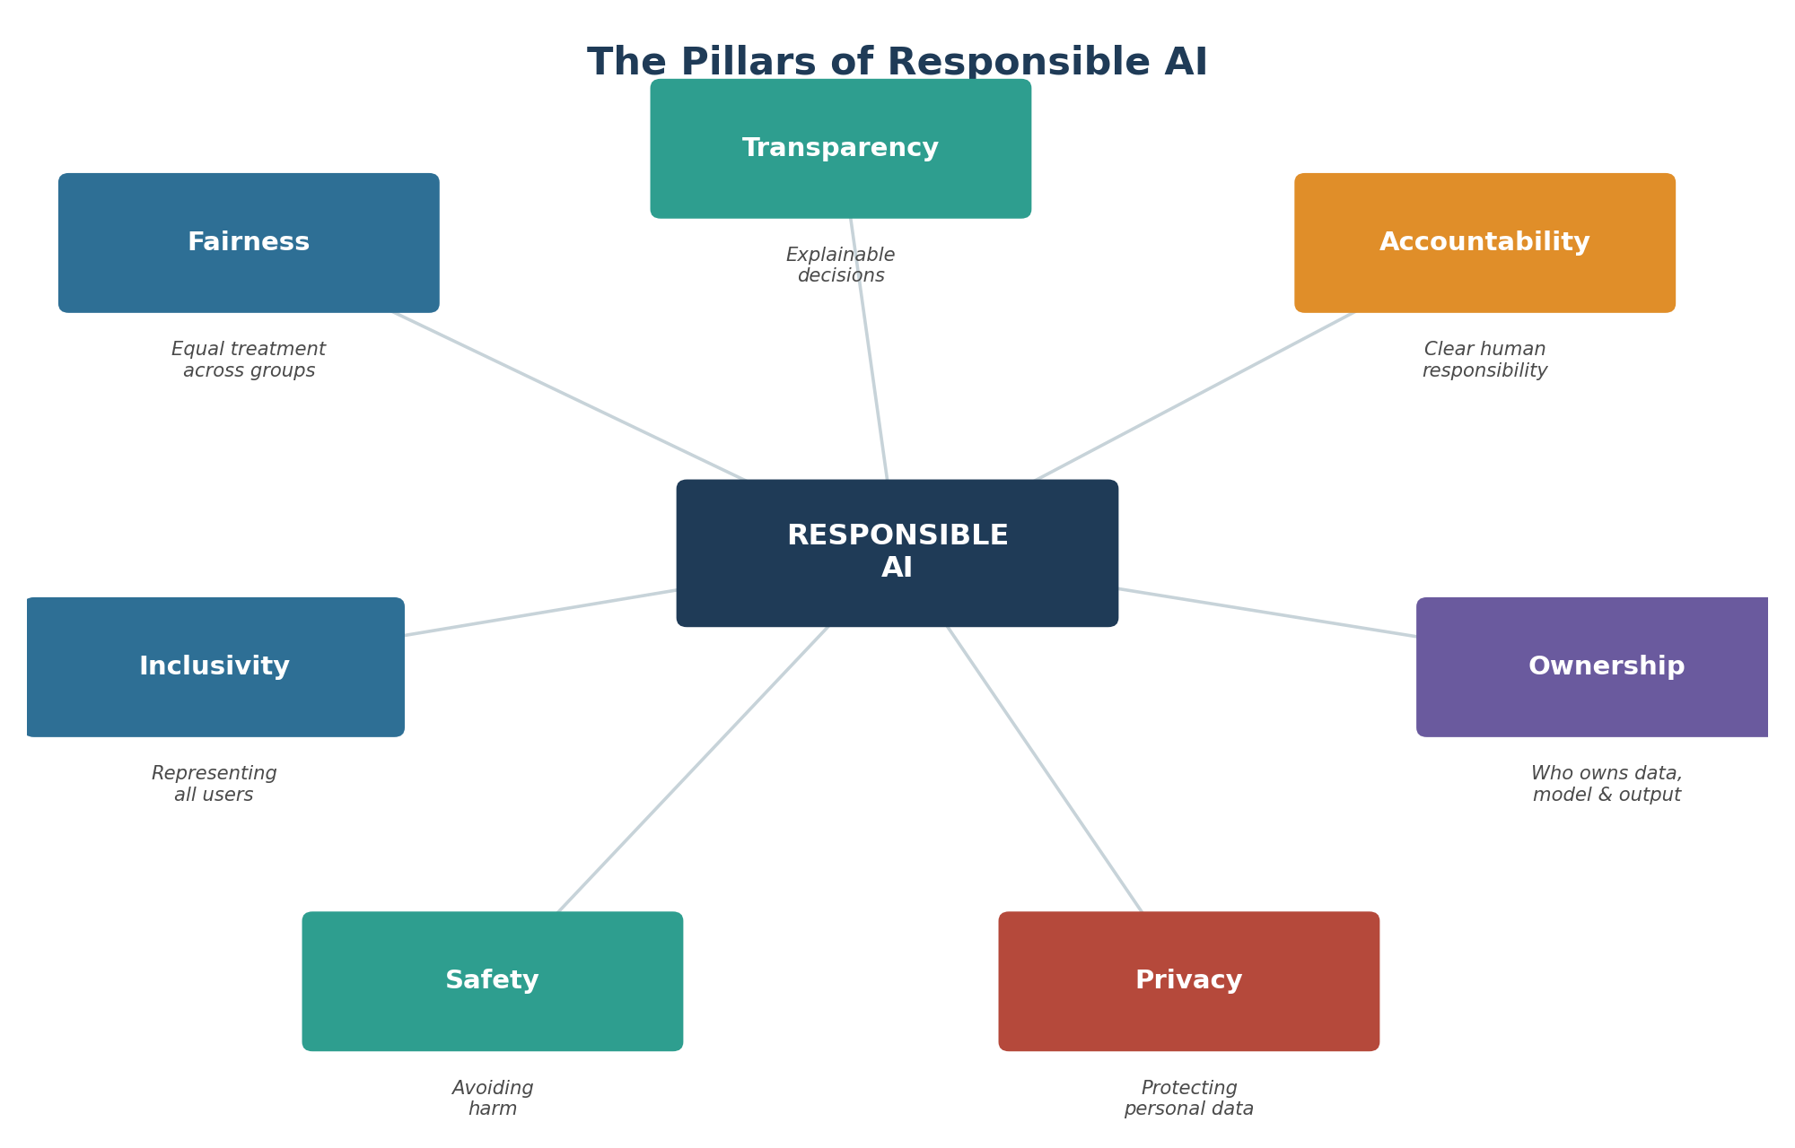
Figure 1: The seven pillars of Responsible AI.

2.1 Pillar Definitions
- Fairness: Ensuring the AI system does not systematically disadvantage any group based on gender, caste, race, religion, or other protected characteristics.
- Transparency: Making the system's logic and decisions understandable — users should be able to know roughly why a decision was made.
- Accountability: Ensuring there is always a responsible human or organisation behind an AI decision, not just ‘the algorithm.’
- Ownership: Clarifying who holds rights over the data used, the trained model, and the content the model generates.
- Privacy: Protecting personal and sensitive data used in training or inference from misuse or leakage.
- Safety: Preventing the system from causing physical, psychological, or financial harm to users or third parties.
- Inclusivity: Designing and testing the system with diverse users in mind, so it performs well for everyone it will serve.

3. Understanding Bias and Fairness
Bias in AI does not usually come from a programmer intentionally writing unfair rules — it almost always comes from the data. If historical data reflects existing social inequalities, a model trained on it will learn and repeat those inequalities unless specifically corrected.

3.1 Common Sources of Bias
- Historical Bias: The training data reflects past discrimination (e.g., fewer women in historical hiring records for technical roles).
- Sampling Bias: The data collected does not represent the full population the model will be used on (e.g., facial recognition trained mostly on one skin tone).
- Labelling Bias: Human annotators introduce their own subjective judgements while labelling training data.
- Measurement Bias: The way a feature is measured or recorded is systematically different across groups.

3.2 What ‘Fairness’ Actually Means
There is no single mathematical definition of fairness — different fairness criteria can even contradict each other. Two commonly taught definitions are:
- Group Fairness (Demographic Parity): Different groups should receive positive outcomes (e.g., loan approval) at roughly similar rates.
- Individual Fairness: Similar individuals, regardless of group, should receive similar outcomes from the model.
Choosing which fairness definition to optimise for is itself a human and policy decision — not something the algorithm can decide on its own.

4. Ownership in the AI Age
Modern AI models, especially generative ones, are trained on enormous amounts of text, images, and code — much of it created by millions of individual people. This has triggered a global debate about who owns what at each stage of the AI pipeline.
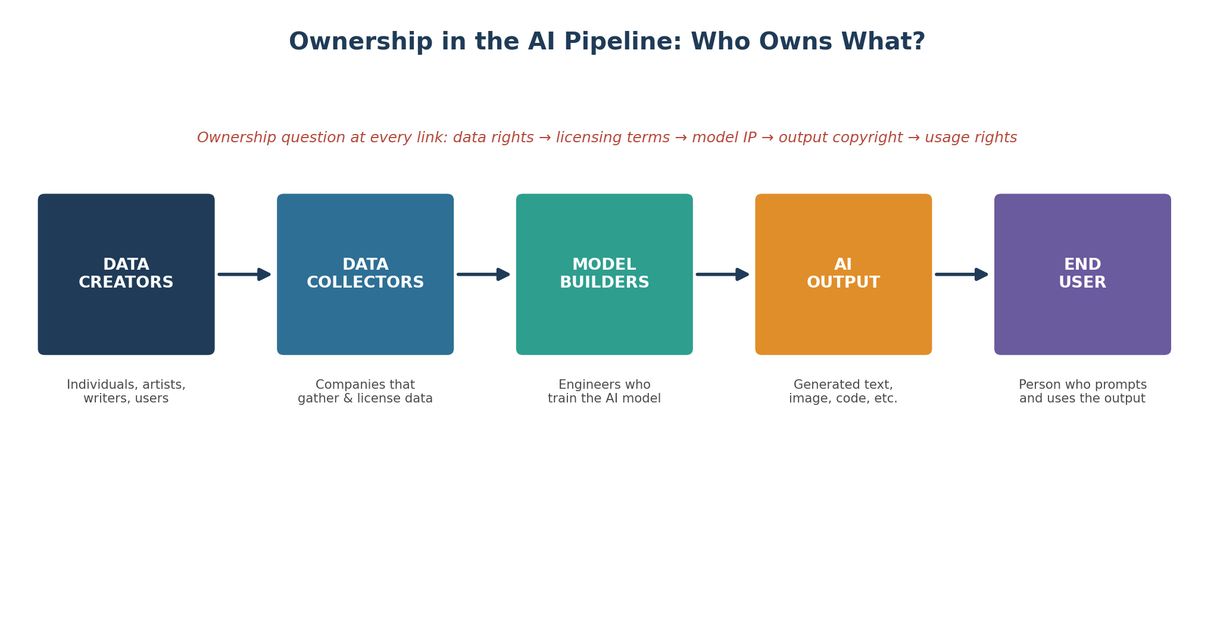
Figure 2: Ownership questions arise at every stage of the AI value chain.

4.1 Three Layers of the Ownership Debate
- Data Ownership: Does a company have the right to train a model on publicly posted content (blogs, art, code) without the original creator's explicit consent?
- Model Ownership: Who owns the trained model itself — the organisation that built it, or in some sense, the millions of people whose data shaped its behaviour?
- Output Ownership: If an AI generates an image, essay, or piece of code, who owns that output — the user who wrote the prompt, the company that built the model, or no one at all?

4.2 Current Thinking (as a Starting Point, Not a Final Answer)
- Most copyright laws currently require human authorship for legal protection, which makes purely AI-generated work's copyright status unsettled in many countries.
- Many AI companies now offer opt-out mechanisms for creators who do not want their content used in training data.
- Some jurisdictions are introducing new regulations requiring AI companies to disclose training data sources.
- Students should always cite and attribute AI assistance transparently in academic or professional work, just as they would cite any other source.

5. Building Fair AI: A Development Lifecycle
Fairness is not a one-time check — it must be considered at every stage of building and maintaining an AI system. The lifecycle below gives a practical, repeatable process.
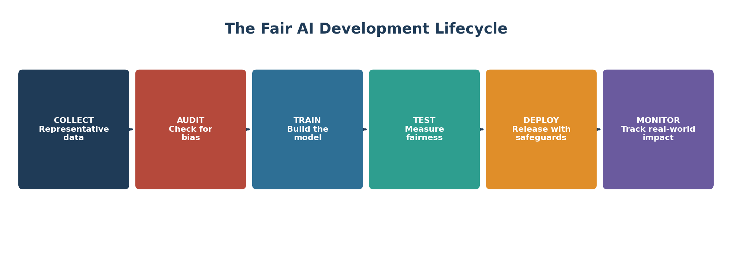
Figure 3: The Fair AI Development Lifecycle — from data collection to ongoing monitoring.
- 1. Collect: Gather data that represents the full diversity of the population the system will serve.
- 2. Audit: Examine the dataset for imbalance or historical bias before any training begins.
- 3. Train: Build the model, applying fairness-aware techniques where needed (e.g., re-weighting underrepresented groups).
- 4. Test: Measure outcomes across different demographic groups using fairness metrics, not just overall accuracy.
- 5. Deploy: Release the system with clear documentation, user disclosures, and human-review safeguards for high-stakes decisions.
- 6. Monitor: Continuously track real-world outcomes after deployment, since bias can emerge over time even in a well-tested model.

6. Real-World Examples to Discuss
- Hiring Algorithms: Several companies have discontinued AI resume-screening tools after discovering they penalised candidates based on gender-coded words or graduation gaps.
- Facial Recognition: Independent audits have repeatedly shown higher error rates for women and people with darker skin tones in some commercial facial recognition systems, prompting bans in some cities.
- Generative Art & Writing: Ongoing lawsuits by artists and authors against AI companies centre on whether training on copyrighted work without consent constitutes infringement — a question still being decided in courts worldwide.
These examples are useful not to criticise any single company, but to understand that fairness and ownership failures are systemic challenges that any team building AI must actively guard against.

7. Open Challenges and Future Directions
- Fairness metrics can conflict with one another — improving one measure of fairness can worsen another.
- Laws on data and AI ownership vary significantly across countries, making global compliance complex.
- Smaller organisations often lack the resources to run full fairness audits that larger companies can afford.
- Public trust in AI depends heavily on transparent communication about both its capabilities and its limitations.
- New frameworks (such as watermarking AI-generated content and consent-based data licensing) are actively being developed and tested.

8. Conclusion
A ‘fair AI, fair future’ is not something that happens automatically as technology improves — it requires deliberate design choices, continuous auditing, and honest conversations about who owns and benefits from AI systems. As future professionals, your responsibility is not only to build systems that work, but to build systems that work fairly for everyone they touch, and to engage thoughtfully with the unresolved question of ownership in the AI age.
Fairness and ownership are not obstacles to innovation — they are the foundations that make AI trustworthy enough to be adopted responsibly at scale.

9. Quick Reference: Glossary
Term | Meaning
Bias | A systematic skew in data or model outcomes that unfairly favours or disadvantages a group
Demographic Parity | A fairness standard requiring similar outcome rates across groups
Explainability | The degree to which an AI's decision process can be understood by humans
Data Licensing | Legal permission granted to use specific data for a defined purpose, such as AI training
Model IP | Intellectual property rights associated with a trained AI model
Watermarking | Embedding an invisible marker in AI-generated content to indicate its origin

